Holidays Task

Goal : using the holidays data (excel workbook) in AWS Quicksight, practice applying similar steps to those that the tutor has shown, to complete these tasks:

Task 1 Add the parks tab from the Holidays data to the data source
- Leave the analysis window in QuickSight and edit the data source of this analysis by selecting Data from the upper toolbar. Then Edit the indicated Data set ‘Holidays’.
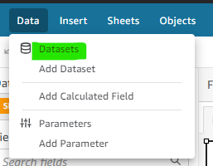

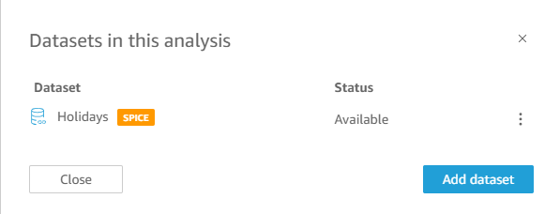

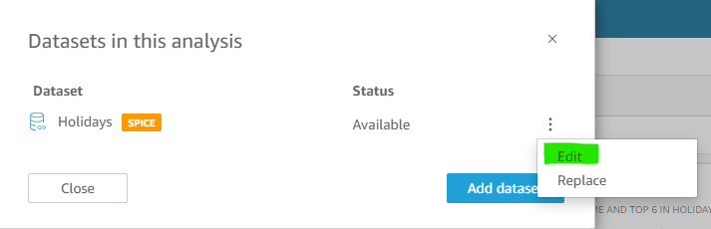

- Once you are in the Data view, follow the same steps as you saw in class to add the Holidays data set (excel workbook) again by uploading the file, before selecting the tab Parks from the Holidays excel source as a new table. You will need to configure and apply the join of your new source table once it is visible on the data source grid.
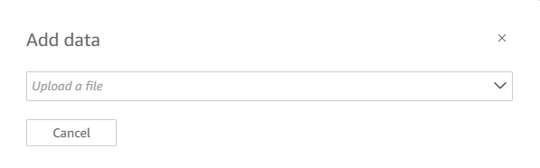
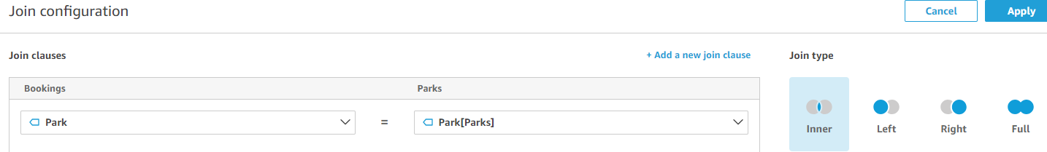

- Confirm your new source is integrated into the data set as expected by previewing full rows of data at the foot of the data window. You should see new columns reflecting the park region (eg Cornwall) and Target (per each park region).
- Note the Target value is duplicated through the join – so to save misuse, add a description to the field
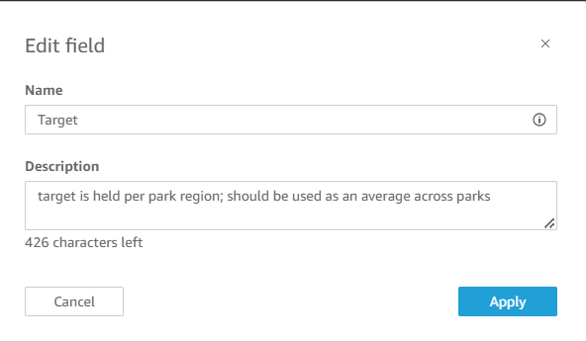
- Your Edited Data Source should match the image below, with three tables connected as inner joins:
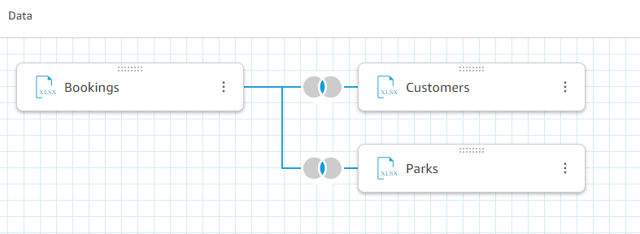
- Publish and Visualise the data (top right options) to return to the analysis/sheet. Keep in mind that the SPICE engine might take a little time to update the data once you have added a new table and joined it, but if there appears to be a lag, you can refresh your browser.

Task 2 Visualise the new table

- In your analysis and on the existing sheet, add a new autograph visual showing the park region which has the highest net revenue. This should add a new horizontal bar chart to your analysis.
- To add the visual, use the + button (top left) and Add visual OR use the Insert drop down menu and select Add Visual. Place the visual on the bottom left of your sheet, under any existing visuals. Leave AutoGraph selected as the visual type and then use Ctrl+Select to highlight the fields ParkRegion and NetRevenue.
- Auto save will remain on throughout this process so your old and new visuals will be saved with the updated data source associated (Holidays)
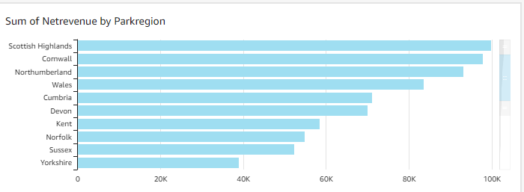

Task 3 Filter the new visual

- Select the visual you added in Task 2.
- From the Filter menu, add a filter for this visual only which shows the top 3 Park Regions by the sum of the net revenue. Your visual should now only contain 3 bars, showing the three regions which pull in the most money overall.
- Ensure the filter is only applied to one visual and the other visuals do not change.
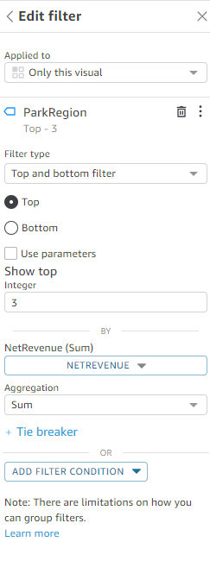

Task 4 Add a detailed tool tip to your new visual

- Add a detailed tooltip to the visual you created in Task 2 by selecting Format Visual from the top right of the horizontal bar chart showing the top 3 park regions
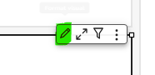 Replace picture
- In addition to Park Region and Net Revenue, add a new field to the tooltip which calculates the average nights spent in each Park Region.
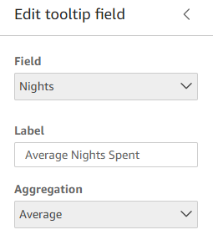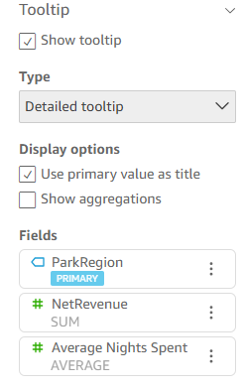
- Hover over the horizontal bar chart to see the tooltip in action and confirm it works as expected.

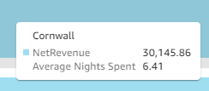

Task 5 Add a Custom action to your analysis

- Following the same steps you have seen in class, add an Action to your analysis using quick create (same sheet visuals) once you have the small multiples ‘Revenue by Arrival Month’ line charts selected. This will mean the Action is driven from this visual.
- Configure the action so that it only affects the Top 3 park regions horizontal bar chart visual but applies to all fields, using a Select action.
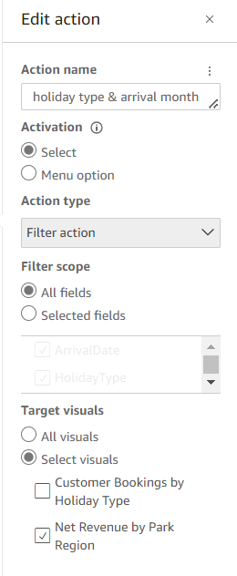
- Test the action by selecting on data points in the small multiples Revenue by Arrival Month time series plots and selecting away from the line charts (in white space) to clear the action.
- Consider which action is easier to drive – the action created in class on the stacked horizontal bar (customer name) or this new action.

